May 2024

KAB is becoming a CIO - Charitable incorporated organisation.

Why is KAB becoming a CIO?
The main benefit of a CIO structure is that while remaining a charity the trustees are not personally liable for the debts or obligations of the charity.

The Board of Trustees have also taken the opportunity to update and modernise the constitution. Below are the main adjustments that have been made:

- A change of name was decided as the word Blind was considered to be old fashioned for our younger generation and to encourage new partially sighted residents to engage with us. Our new name will be Kingston Sightloss Support. We will still be known as KAB for some time and the new name will be phased in gradually over the coming year.

- We have increased our geographical reach of our membership to include those who live in the Royal Borough of Kingston Upon Thames as well as the surrounding areas.

- Following the covid crisis we have added the option to be able to conduct our business remotely, electronically.

Above are the main changes, however, if you would like to receive the full new constitution, please contact the office and state the format you require, i.e. large print, electronically or audio.

We hope to see you at our AGM on the 11th June 2024.

Thank you for your help and Support.

Warmest regards,

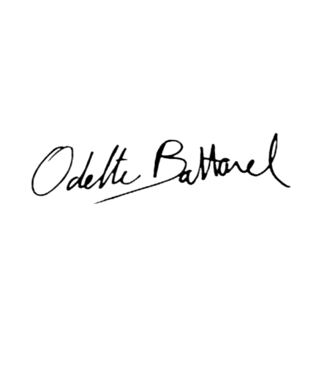
Odette Battarel CEO
pp

Roy F Smith MBE
Chair of Trustees

